SPCE
The Society of Professors in Christian Education

OPPORTUNITIES FOR SPONSORS AND EXHIBITORS

THURSDAY OCTOBER 26—SATURDAY OCTOBER 28, 2023

Westin O’Hare Hotel, Chicago, Illinois

Dear Friends,

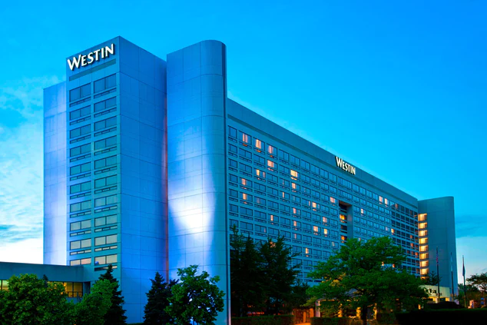
Please join us as a sponsor or exhibitor at the Annual SPCE Conference in Chicago, Thursday-Saturday, October 27-29, 2023 at the Westin O’Hare, 6100 North River Road, Rosemont, IL 60018.

Who we are? SPCE is a leading scholarly guild for evangelical academicians in the field of practical theology, particularly in the disciplines of education, discipleship, and ministry leadership.

Our membership is comprised primarily of professors, ministry practitioners, and doctoral students, all of whom are devoted to increasing depth and excellence in the teaching ministry of the church and the academy. The primary function of our organization is the annual conference, held each year in October. The conference serves as a means of equipping our members through scholarly dialogue, professional development, and networking.
What do we do?
We gather to further the field of Christian Education through cooperative networking, scholarly contributions, and critical engagement with the varied practices of Christian Education and other related disciplines.

What core values govern our work?
- Service to Christ’s church
- Critical thinking and scholarship
- Collegial and collaborative relationships
- Dialogue with people from distinct backgrounds and contexts

Our Annual Conference: Attending the SPCE conference provides educators with a spectrum of opportunities to both enrich their professional lives and contribute to the field of Christian Education. Many exhibitors have expressed how the conference is a professional development opportunity for them, which includes renewing old relationships with like-minded practitioners and the chance to establish new ones. Thought leaders from colleges, seminaries, and para-church organizations attending the conference represent thousands of up-and-coming leaders across the country.
Conferences Theme: Generational Intelligence has informed our discipline as a great value for learning and growth for bringing the generations together. In an attempt to describe the generations with nomenclature designed to be helpful glimpses into the characteristics of a generation, we have all been categorized. We are baby boomers, Gen X-ers, Millennials, or Gen Z. Whether right or wrong, no one fits entirely into a category because humans are unique and complex beings that need one another. Each generation offers a perspective of God from a unique stage of growth.
Plenary Speakers Dr. A. J. Swoboda (Bushnell University) and Dr. Holly Chatterton Allen, (Lipscomb University) will help us explore intergenerational intelligence through the combination of developmental theory with intergenerational methodology in the challenges of teaching and learning to and from the generations. Our goal is to build bridges to the generations through generational intelligence and gaining a posture of learning from one another as the church and the academy work together.
Exhibitor Space: The hotel facilities are outstanding, and exhibits will be in the ballroom with plenary session. Tables will be the standard 6’ long x 30” wide. Exhibit space is open throughout the conference providing maximum opportunities for connecting with educators.
Connecting with Delegates: Exhibits are always open in the ballroom, and we have designated breaks for delegates to connect with exhibitors (see conference schedule below). We also suggest that exhibitors: 1.) Bring giveaways or collect business cards in a bowl/box for a drawing (bring 3x5 cards for people who don’t have business cards with them); and 2.) bring order forms that offer a discount when ordering at the conference or by mail before Thanksgiving (or offer a discount code to order online by Thanksgiving).

Registration: There are several opportunities for your organization to exhibit at the conference, and we strive to ensure that you will receive a strong return on your investment. Please visit our exhibitor webpage to explore your options or see the sponsor and exhibitor opportunity below. You may register online or by mail with the form below.
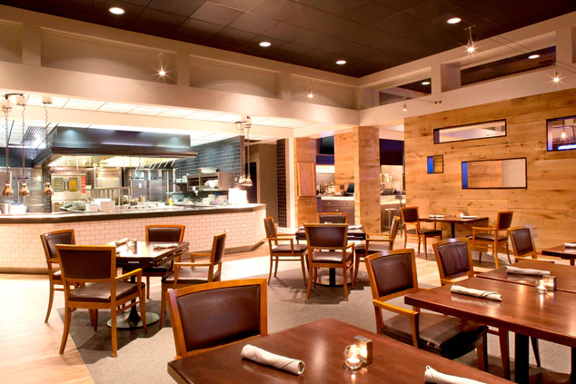
As you plan for this fall’s conference, please contact me if you have any questions. With a great location, superior program and excellent pricing, we believe this will be the most well-attended SPCE Conference ever. We would love for you to join us!

Blessings,
Mark
Mark Cannister, Ed.D.
Executive Administrator
Society of Professors in Christian Education
255 Grapevine Road, Wenham, MA 01984
mark.cannister@gordon.edu www.spceonline.org

Exhibitor and Sponsor opportunities.
Payment with contract should be made no later than August 15th.

Many exhibitors and sponsors attend both the SPCE and AYME Conferences, which dovetail with each other at the same venue. For those attending both conferences please see the “Combo Registration” fee, which is lower than registering for each conference individually. And if you need an additional registration or table, you just pay once for that addition as part of the Combo registration.

Option 1 Program Advertising: $100—$250 SPCE/AYME Combo Prices: $200—$500
Full-page color ad for $250 or Combo $500 for both conferences.
Half-page full-color ad for $150 or Combo $300 for both conferences.
Quarter-page full-color ad for $100 or Combo $200 for both conferences.

Option 2 General Exhibitor: $200 or Free Book SPCE/AYME Combo Price: $300
You may send catalogs and/or promotional materials for distribution to the attendees.
We will distribute promotional materials for your organization when accompanied by a free book, another significant resource, or $200 fee. You may combine options 1 & 2.

Option 3 Unattended Exhibit Table: $300 SPCE/AYME Combo Price: $500
Allow us to handle your exhibit table. When it is impossible to have a representative at the conference, you can still exhibit your resources with this option.
- One unattended exhibit table (tablecloth and skirt)
- One item placed on the Conference Registration table.
- Quarter-page ad in the Conference Program. (Upgrade to half-page ad for $100 or Combo $200, full page ad $200 or Combo $350.)
- Logo posted on the SPCE website.

Option 4 Standard Exhibitor: $600 SPCE/AYME Combo Price: $1,000
- One exhibit table (tablecloth, skirt, and chairs)
  - Additional exhibit tables $100 each.
- One item placed on the Conference Registration table.
- Quarter-page ad in the Conference Program. (Upgrade to half-page ad for $100 or Combo $200, full page ad $200 or Combo $350.)
- Logo posted on the SPCE website.
- Access to the current SPCE membership list upon request.
- One-conference registration including meals served at the conference.
  - Additional exhibitor registrations $150/person.

Option 5 Bronze Sponsor: $1,000 SPCE/AYME Combo Price: $1,500
- Three exhibit tables (tablecloth, skirt, and chairs)
  - Additional exhibit tables $100 each.
- One item placed on the Conference Registration table.
- Logo on the SPCE website registration page.
- Half-page ad in the Conference Program. (Upgrade to full page ad $100 or Combo $200.)
- Access to the current SPCE membership list upon request.
- Two-conference registrations including meals served at the conference.
- Additional registrations $150/person.
- One Complimentary full-page ad in the December issue of the Christian Education
Journal, upon request.
- A 10min. marketing opportunity to the entire group at a general session
with one item at each place setting (supplied by sponsor).
Option 6 Silver Sponsor: $2,000 SPCE/AYME Combo Price: $3,000
    - Three exhibit tables (tablecloth and skirt).
  - Additional exhibit tables $100 each.
    - One item placed on the Conference Registration table.
- Logo on the SPCE website.
    - Full-page ad in the Conference Program.
    - Three-conference registrations including all conference meals.
- Additional registrations $150/person.
- Your ad emailed to the SPCE membership list.
    - Access to the SPCE membership list upon request.
- One Complimentary full-page ad in the December & April issues of the Christian
Education Journal, upon request.
- A 12min. marketing opportunity to the entire group at a general session
with one item at each place setting (supplied by sponsor).
Option 7 Gold Sponsor: $3,000 SPCE/AYME Combo Price: $4,000
    - Three exhibit tables (tablecloth, skirt, and chairs).
  - Additional exhibit tables $100 each.
    - One or two items on the Conference Registration table.
    - Logo on the SPCE website.
    - Full-page ad in the Conference Program.
    - Three conference registrations including all conference meals.
- Additional registrations $150/person.
- Your ad emailed to the SPCE membership list.
    - Access to the SPCE membership list upon request.
    - One Complimentary full-page ad in the December, April, & August issues of the
Christian Education Journal, upon request.
    - A 12min. marketing opportunity to the entire group at the opening general session with one item at each place setting (supplied by sponsor).

SHIPPING & RECEIVING PROCEDURES
The hotel requests that packages arrive no earlier than three (3) days prior to the date required. Packages should be labeled and identified as follows, please contact the hotel operator upon arrival to retrieve your packages.

Please address shipments as follows:

The Westin O’Hare Hotel
Your Company/Organization; Name of On-Site Contact
Convention/Event Name, Date of Event
6100 North River Road
Rosemont, IL 60018
Box 1 of _____

Your organization is responsible for all expenses of shipping materials to and from the hotel, including storage/drayage fees. The Westin O’Hare charges $7.00 per box (0-5 lbs.); $15/box (6-20 lbs.); $20/box (21-50 lbs.), $50/box (over 50 lbs.), $100/crate, and
$100/pallet for incoming materials. For materials shipped upon the conclusion of the conference the hotel charges $5.00 for each box. Boxes will be received no earlier than 3-days prior to the conference. For complete hotel policies on shipping, receiving, and storage, please contact our Hotel Event Manager: Lasandra Blocker at the Westin O’Hare: lasandra.blocker@westin.com 847-698-1397.

EXHIBIT SETUP
Exhibits will be set-up in the SPCE ballroom. You will be able to begin setting up your display Thursday afternoon prior to the start of the conference. Setting up your display at this time allows attendees to browse the exhibits during registration prior to dinner.

HOTEL & GROUND TRANSPORTAION
Airport/Hotel ground transportation and hotel room registration information (SPCE has a discounted rate of $119/night) is available on the SPCE website: www.spceonline.org

THE SPCE CONFERENCE SCHEDULE
Exhibit tables are located around the perimeter of the ballroom and are essentially open throughout the conference. We intend for exhibitors to be part of the SPCE family, eating in the ballroom with attendees, and attending general and breakout sessions as they desire.

THURSDAY, OCTOBER 26, 2023
2:00-6:00pm Registration & Exhibits Open
6:00-8:30pm Dinner and Plenary 1 with Dr. A. J. Swodoba
United We Flourish: Intergenerational Intelligence
8:30-9:00pm Dessert Reception in Honor of New Member

FRIDAY, OCTOBER 27, 2023
7:00-8:00am Breakfast on your own & Exhibits Open
8:30-9:30am Breakout Presentations 1
9:45-10:45am Breakout Presentations 2
10:45-11:00am Break and & Exhibits Open
11:00-1:45pm Lunch & Business Meeting, Plenary 2 with Dr. A. J. Swoboda
Integrating Streams of Development for Teaching & Learning
1:45-2:00pm Break and & Exhibits Open
2:00-3:00pm Breakout Presentations 3
3:00-3:30pm Refreshment Break
3:30-5:00pm Breakout Presentations 4
5:00pm… Explore Chicago: Dinner on your own and Networking

SATURDAY, OCTOBER 28, 2023
7:00-9:00am Breakfast on your own & Exhibits Open
9:00-10:00am Plenary Session 3 with Dr. Holly Chatterton Allen
Embracing Intergenerational Formation I
10:00-10:30 Exhibits Open
10:30-11:30am Plenary Session 4 with Dr. Holly Chatterton Allen
Embracing Intergenerational Formation II
11:30am Conference Closes

SPCE SPONSOR AND EXHIBITOR CONTRACT 2023

Please complete this contract and indicate which option your organization will be choosing for this year’s SPCE conference. Exhibitor cancellation requests must be made at least 30 days prior to the conference.

Name of Organization________________________________________________________

Contact person_______________________________________________________________

Address_____________________________________________________________________

City State Zip_________________________

Office Phone: Cell:_________________________

E-mail: Amount of check enclosed: $__________

Names of people who will represent your organization at the conference.

1. ________________________________________________

2. ________________________________________________

Please check the option and add-ons you are choosing for this year’s conference.

Option 1 ___ Program Advertising: Full-page $250, or ____Combo $500;
___Half-page $150, or ____Combo $300, ____ Quarter-page $100, or ____Combo $200
Option 2 ___ General Exhibitor: $200, or ____Combo $300
Option 3 ___ Unattended Exhibit Table: $300, or ___Combo $500 (1 table, 0 exhibitors)
Option 4 ___ Standard Exhibitor: $600, or ___Combo $1,000 (1 table, 1 exhibitor)
Option 5 ___ Bronze Sponsor: $1,000, or ___Combo $1,500 (3 tables, 2 exhibitors)
Option 6 ___ Silver Sponsor: $2,000, or ___Combo $3,000 (3 tables, 3 exhibitors)
Option 7 ___ Gold Sponsor: $3,000, or ___Combo $4,000 (3 tables, 3 exhibitors)
Add-on ___ Additional Tables: $100 each
Add-on ___ Additional Registrations: $150 each
Upgrade Options 3 or 4 to: ____half-page ad for $100 or ____Combo $200;
____ full page ad $200 or ____Combo $350.
Upgrade Option 5 to: ____full page ad $100 or ____Combo $200.

Please mail this completed form with the appropriate check payable to SPCE to:

Dr. Mark Cannister, Administrator
Society of Professors in Christian Education
255 Grapevine Road
Wenham, MA 01984

Questions? Please email me at: mark.cannister@gordon.edu

